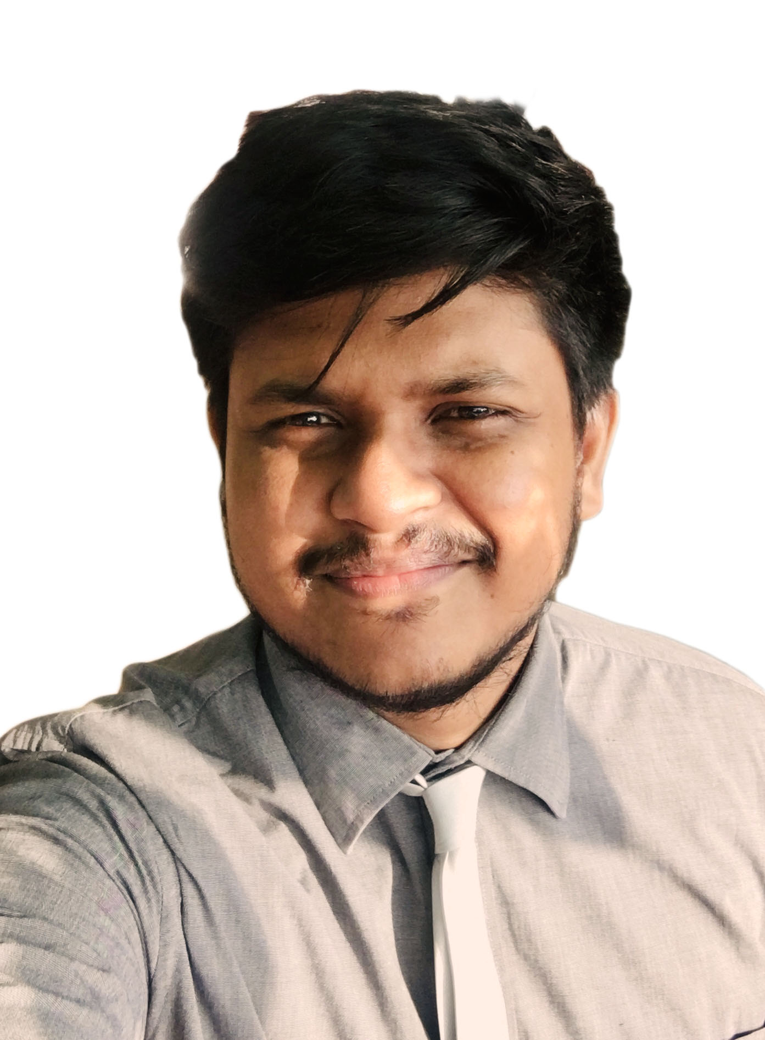
E.M.S.P.M Rathnayake
supun.rathnayake007@gmail.com
Portfolio Site: supunrathnayake007.github.io/
linked-In: www.linkedin.com/in/supun-rathnayaka/

127/2 Malapalla, Pannipitiya, western province,
10230, Sri Lanka
+94725340075

I'm deeply passionate about web development, with a focus on creating dynamic and visually captivating online experiences. My expertise lies in crafting responsive websites, seamlessly integrating both front-end and back-end functionalities. I bring enthusiasm to my work, particularly enjoying the creative process of building engaging digital platforms. My skill set extends to utilizing various frameworks, enhancing the overall user experience

Key Skills
I am actively focusing on honing my skills in ReactJS, Next.js, and Tailwind CSS, as I believe these technologies are pivotal in the contemporary web development landscape. Alongside these, I possess proficiency in fundamental web technologies like HTML, JavaScript, and CSS, which I consider essential for any developer. Additionally, I have acquired expertise in Python, Flask, MongoDB, MySQL, MS SQL, SQLite, and C# over time. While these skills may not be directly central to the specific job at hand, they contribute to my versatility and a broader understanding of various tools and languages in the realm of software development

Projects
I've started several personal web development projects to showcase my skills, including a Portfolio website using ReactJS and Tailwind which hosted at 'supunrathnayake007.github.io'. This platform, intentionally designed for skill demonstration, features a user-friendly interface, and dedicated 'Projects' tab listing all projects that I am working on, and a Contact page for easy communication.

University Education
Enrolled in a B. Sc. Special (Hons) IT degree at Sri Lanka Institute of Information Technology in 2014. During my studies, I successfully completed several prototype projects, including a Hospital Management System, Inventory Management system, and a travel planning blog. In 2016, I made a proactive decision to leave my academic path and pursue a fulfilling opportunity in software development, the job of my dreams. Believing in the significance of practical knowledge, I embraced this career move to gain hands-on experience and contribute actively to the dynamic field of software development.

School Attempt
I did my O'Levels at Kottawa Ananda Vidyalaya in 2009, scoring well in Math and Science (A). I also did fine in Religion and History (B), IT, Arts, and English (C), and Language and Commerce (S). Then, at Kottawa Dharmapala Vidyalaya for A'Levels in 2013, I got a C in Physics and an S in Combined Math and Chemistry. These school years not only taught me the basics but also sparked my interest in problem-solving and analytical thinking.

Working Experience
- software developer and client support agent at iOM Lanka (Private) Limited (24/10/2016 to 28/02/2020) and reported to project manager
- System Executive at HNB Finance in Business System development department and maintained few internal systems with collaborating software vendors and development teams (Period -From 19/10/2020 to 2021)

After taking some off time I came back to development (2023) as web developer by self studying and then build a portfolio site using React

